University of Central Punjab
FOIT & CS
Work Sheet-1

Course Title | Probability and Statistics | Course Code
Course Instructor |  | Section
Time Allowed |  | Total Marks
Student Name |  | Registration No.

Question 1
The data are the number of machines in a gym. You sample five gyms. One gym has 12 machines, one gym has 15 machines, one gym has ten machines, one gym has 22 machines, and the other gym has 20 machines. What type of data is this? -> QUANTITATIVE (DISCRETE).

Question 2
The data are the weights of backpacks with books in them. You sample the same five students. The weights (in pounds) of their backpacks are 6.2, 7, 6.8, 9.1, 4.3. Notice that backpacks carrying three books can have different weights. What type of data is number of bags and what type of data are weights? -> QUANTITATIVE (CONTINUOUS)

Question 3
The data are the areas of lawns in square feet. You sample five houses. The areas of the lawns are 144 sq. feet, 160 sq. feet, 190 sq. feet, 180 sq. feet, and 210 sq. feet. What type of data is this? -> QUANTITATIVE (CONTINUOUS)

Question 4
You go to the supermarket and purchase three cans of soup (19 ounces tomato bisque, 14.1 ounces lentil, and 19 ounces Italian wedding), two packages of nuts (walnuts and peanuts), four different kinds of vegetable (broccoli, cauliflower, spinach, and carrots), and two desserts (16 ounces pistachio ice cream and 32 ounces chocolate chip cookies). Name data sets that are quantitative discrete, quantitative continuous, and qualitative.
Type of Data | Examples
Quantitative Discrete | 3 cans of soup; 4 vegetables; 2 nut packages; 2 desserts
Quantitative Continuous | Soup weights: 19 oz, 14.1 oz, 19 oz; Dessert weights: 16 oz, 32 oz
Qualitative | Vegetable types: broccoli, cauliflower, spinach, carrots; Nut types: walnuts, peanuts

Question 5
Work collaboratively to determine the correct data type (quantitative or qualitative). Indicate whether quantitative data are continuous or discrete.
- the number of pairs of shoes you own. QUANTITATIVE -> DISCRETE
- the type of car you drive. QUALITATIVE
- the distance it is from your home to the nearest grocery store. QUANTITATIVE -> CONTINUOUS
- the number of classes you take per school year. QUANTITATIVE -> DISCRETE
- the type of calculator you use. QUALITATIVE
- weights of sumo wrestlers. QUANTITATIVE -> CONTINUOUS
- number of correct answers on a quiz. QUANTITATIVE -> DISCRETE
- Duration (amount of time). QUANTITATIVE -> CONTINUOUS
- The colours of the houses around the park. QUALITATIVE
- number of tickets sold to a concert. QUANTITATIVE -> DISCRETE
- percent of body fat. QUANTITATIVE -> CONTINUOUS
- favourite baseball team. QUALITATIVE
- time in line to buy groceries. QUANTITATIVE -> CONTINUOUS
- number of students enrolled at Evergreen Valley College. QUANTITATIVE -> DISCRETE
- most-watched television show. QUALITATIVE
- brand of toothpaste. QUALITATIVE
- distance to the closest movie theatre. QUANTITATIVE -> CONTINUOUS
- age of executives in Fortune 500 companies. QUANTITATIVE -> CONTINUOUS
- number of competing computer spreadsheet software packages. QUANTITATIVE -> DISCRETE

Question 6
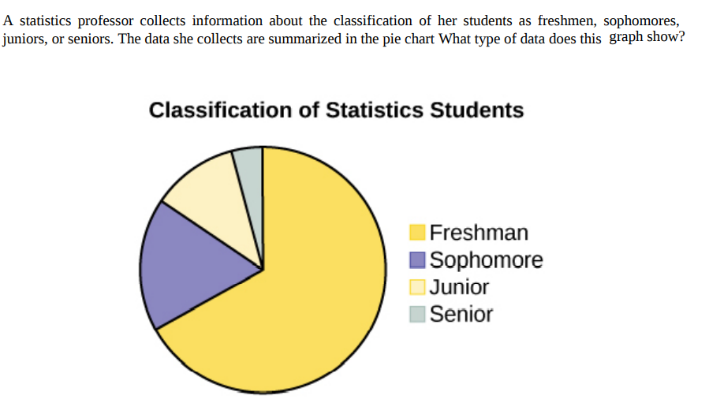

Question 7
Classify the following statements as Descriptive and Inferential Statistics
- The average age of the students in this class is 21 years.
- At least 5% of the killings reported last year in city X were due to tourists.
- Of the students enrolled in Debre Markos University in this year 74% are male and 26% are female.
- The chance of winning the Ethiopian National Lottery in any day is 1 out of 167000.

Question # 8
Match the following:

Ordinal scale level | data that cannot be ordered nor can it be used in calculations
Interval scale level | data with a starting point that can be ordered; the differences have meaning and ratios can be calculated.
Nominal scale level | data that can be ordered; the differences cannot be measured
Ratio scale level | data with a definite ordering but no starting point; the differences can be measured, but there is no such thing as a ratio.
Watched
Question # 9
What type of measure scale is being used? Nominal, ordinal, interval or ratio
a. High school soccer players classified by their athletic ability: Superior, Average, Above average _________________Ordinal
b. Baking temperatures for various main dishes: 350, 400, 325, 250, 300 _________Interval
c. The colors of crayons in a 24-crayon box __________________Nominal
d. Social security numbers _____________________Nominal
e. Incomes measured in dollars ____________________Ratio
f. A satisfaction survey of a social website by number: 1 = very satisfied, 2 = somewhat satisfied, 3 = not satisfied _________________ Ordinal
g. Political outlook: extreme left, left-of-center, right-of-center, extreme right ___ Nominal
h. Time of day on an analog watch __________________Ratio
i. The distance in miles to the closest grocery store _______________Ratio
j. The dates 1066, 1492, 1644, 1947, and 1944 _________________ Nominal
k. The heights of 21–65 year-old women _________________ Ratio
l. Common letter grades: A, B, C, D, and F _______________ Ordinal
Question # 10
Classify each as nominal-level, ordinal-level, interval level, or ratio-level measurement.
a. Pages in the 25 best-selling mystery novels. Ratio
b. Rankings of golfers in a tournament. Ordinal
c. Temperatures inside 10 pizza ovens. Interval
d. Weights of selected cell phones. Ratio
e. Salaries of the coaches in the NFL. Ratio
f. Times required to complete a chess game. Ratio
g. Ratings of textbooks (poor, fair, good,excellent). Ordinal
h. Number of amps delivered by battery chargers. Ratio
i. Ages of children in a day care center. Ratio
j. Categories of magazines in a physician’s office (sports, women’s, health, men’s, news). Nominal

